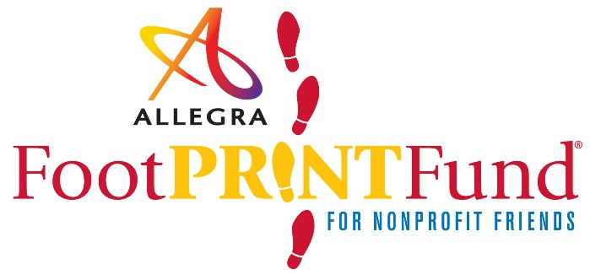
APPLICATION FOR 2017 FOOTPRINT FUND
Deadline: February 17, 2017

PURPOSE

Community support is a core value at Allegra. The FootPRINT Fund is designed to aid non-profit organizations in their quest to create lasting impressions. Our hope is that the FootPRINT Fund® will help local organizations and associations leave their “footprints” in our community through increased awareness and visibility. We invite each non-profit to use these marketing and print service awards to build a better community, one step at a time.

APPLICATION GUIDELINES

Who is Eligible?
The FootPRINT Fund® is available to any non-profit group, association or charitable organization in Hamilton
and area that meets the FootPRINT Fund® selection criteria. Priority will be given to non-profit groups that have not been awarded FootPRINT Fund® in the past.

What are the Selection Criteria?
Applications are reviewed by a panel of representatives from Allegra along with members of the local community.
The panel responds in writing to all applications that are submitted in accordance with the application deadline. Organizations should not assume an award has been given until such notification. Any eligible organization or association can apply and need not be a customer of Allegra.

What Can I Apply For?

Design services
- Logo enhancement or modification
- Page design or layout (per below items)

Printing
- Brochure • Pamphlet • Rack Card
- Insert • Flyer • Poster

Signs
- Signs/ banners (Up to 60”)
- Vinyl banner
- Banner stand
- Coroplast or foamcore sign

What is Not Offered
Through Footprint Fund®?

- Web services
- Stationery
- Vehicle Graphics
- Promotional & Apparel items
- Mailing services
- Marketing services

more information, contact (905) 528-2999 visit our website at www

FOOTPRINT FUND® AWARD TERMS & CONDITIONS

All awarded print services must be used in the calendar year that they are awarded. Awards may only be used for projects originating during current year and not to offset any existing balances due to Allegra. The application deadline is February 17, 2017. Applicants receiving an award will be notified by March 14, 2017. Please note that any materials produced through the FootPRINT Fund® must clearly display the FootPRINT Fund® logo. All materials produced through FootPRINT Fund® must be promotional in nature. Materials printed through FootPRINT Fund® must be designed by Allegra. Allegra reserves the right to use any FootPRINT recipient’s name, logo and FootPRINT story in marketing materials and online.

PLEASE PROVIDE A DETAILED APPLICATION FOR CONSIDERATION

Organization Name: .................................................................................................................................... Charitable #: ....................................................

Address: ....................................................................................................................................................................................................................................................

City: ......................................................................................................................................................................... Postal Code: ....................................................

Primary Contact: .............................................................................................................................................Telephone: ........................................................

Email: ...........................................................................................................................................................................................................................................................

Website: ...................................................................................................................................................................................................................................................... Years organization has been in existence: ...............................................................................

How did you hear about FootPRINT Fund®?

Primary purpose of organization. Briefly tell us what your organization does? What is your mission? Who do you serve?

What are you applying for?
Award recipients are selected based upon how the marketing and print services will be used to further the organization’s goals. Review the categories below and submit your application for the most appropriate category. Please include quantities requested if applicable.

FOOTPRINT FUND CATEGORY (Please choose one)

Service expansion
Use of services to contribute to expanding an organization’s awareness or existing service projects.
How can we help you to grow?

Program enhancements
Use of services to promote new programs or projects. How can we help you to enhance something new?

Leveraged efforts
Use of services to increase the impact of other existing resources.
How can we help to expand your current communications efforts?

Certification: I certify that the information contained in this application is true and correct to the best of my knowledge, and that I have the authority to request funds for the organization named above.

Name: ..........................................................................................................................................................................................................................................................

Title/Position within organization: .......................................................................................................................................................................................

SUBMIT FORM

